**Synopsis Report**

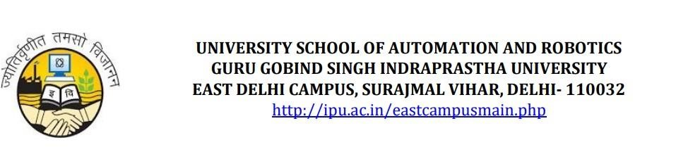

***Chatfolio*: Your AI-Powered Interactive Portfolio**

Submitted in fulfilment of the requirements for the completion of major project during 8th semester

**Name: Kushagra Wadhwa**

**Enrolment Number: 08719011621**

**Under the supervision of**

**Dr Sushobhan Chowdhury**

**Introduction**

Traditional portfolio websites, while effective in showcasing an individual’s skills, projects, and experiences, often fail to engage users meaningfully. They present static information that lacks interactivity and personalization, which are critical in today’s competitive professional landscape. This project introduces *Chatfolio*, an AI-powered chatbot designed to revolutionize personal branding by enabling dynamic, conversational interactions. Chatfolio allows recruiters, clients, and collaborators to directly engage with an AI representation of the user, offering a futuristic and engaging self-presentation method.

**Problem Statement**

Professionals often struggle to differentiate themselves in a saturated job market due to limitations in current portfolio solutions:

* **Lack of Interactivity**: Static websites provide information but fail to engage users or encourage deeper exploration.
* **Technical Barriers**: Building and maintaining a portfolio website often requires web development skills (e.g., MERN stack), which not all professionals possess.
* **Impersonal Presentation**: Traditional portfolios fail to convey personality or soft skills, leaving recruiters with an incomplete understanding of the candidate.

These challenges highlight the need for a more interactive, accessible, and personalized solution for showcasing professional achievements.

Chatfolio addresses these challenges by integrating conversational AI into portfolio presentation. Key features include:

* **Dynamic Interaction**: Users can converse with the AI to explore the professional’s resume, skills, and projects in detail.
* **Personalization**: The AI adapts responses based on user queries and past interactions.
* **Ease of Use**: No coding skills are required; users simply provide their data for integration into the chatbot.

This innovative approach transforms static portfolios into engaging experiences that better capture a professional’s unique value.

**Literature Survey**

To ensure Chatfolio leverages cutting-edge technology, the following research areas are explored:

1. **Conversational AI in Personal Branding**: Studies on how chatbots enhance user engagement and improve personal branding outcomes.
2. **Large Language Models (LLMs)**: Research on fine-tuning models like GPT-4 or Llama 3 for domain-specific applications.
3. **AI in Recruitment**: Analysis of how recruiters use AI-driven tools for candidate screening and interaction.

These studies underscore the growing importance of AI in professional contexts and validate Chatfolio’s potential impact.

**Proposed AI Model**

Chatfolio will utilize advanced AI technologies to deliver seamless and human-like conversations:

* **Base Model**: Options include GPT-4, Llama 3, or Mistral based on performance and cost considerations.
* **Fine-Tuning**: The model will be trained on user-specific data (e.g., resumes, projects) to ensure contextual accuracy.
* **Retrieval-Augmented Generation (RAG)**: Vector databases (e.g., Pinecone, FAISS) will enable efficient retrieval of structured information.
* **Memory & Personalization**: The chatbot will remember user interactions for improved continuity and engagement.

This architecture ensures Chatfolio provides accurate, context-aware responses tailored to individual users.

**Features & Functionalities**

Chatfolio offers a range of innovative features designed to enhance user experience:

1. **Conversational Resume Exploration**:
   * Users can ask questions like "What are your key skills?" or "Describe your latest project."
   * The bot dynamically generates responses based on stored data.
2. **Context-Aware Responses**:
   * Fine-tuned understanding of technical terms and job roles ensures relevant answers.
   * Personalized responses adapt based on previous interactions.
3. **Interactive Project Showcase**:
   * Projects can be presented step-by-step with code snippets, diagrams, or detailed explanations upon request.
4. **AI-Generated Resume Insights**:
   * Tailored resume versions for specific roles.
   * Customized cover letters generated from job descriptions.
5. **Adaptive Learning & Feedback**:
   * Tracks recruiter queries to suggest resume improvements.
   * Optional voice interaction for enhanced accessibility.
6. **External Service Integration**:
   * LinkedIn/GitHub synchronization for automatic updates.
   * Scheduling tools like Calendly for interview management.
   * Email drafting capabilities for follow-ups.

**GANTT/PERT Chart (Project Timeline)**

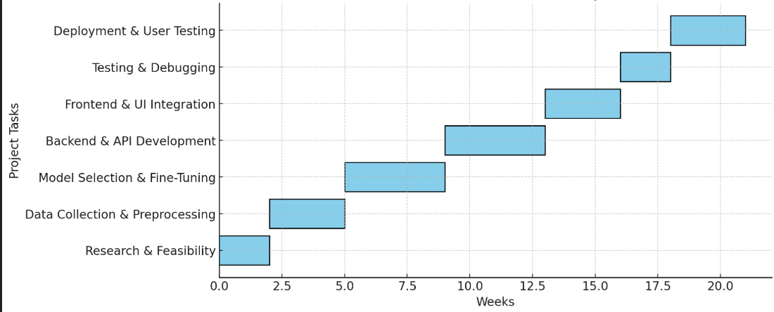

**Hardware and Software Requirements**

1. **Hardware**:
   * GPU-enabled servers for efficient model inference.
   * Cloud storage solutions for secure data handling.
2. **Software Stack**:
   * *AI Frameworks*: OpenAI API, Hugging Face Transformers, LangChain.
   * *Backend*: Python frameworks like FastAPI or Flask.
   * *Frontend*: React.js with chatbot UI components.
   * *Database*: PostgreSQL for user data; Pinecone/FAISS for vector storage.
   * *Hosting*: AWS/GCP/Hugging Face Spaces for scalable deployment.

|  |  |  |  |
| --- | --- | --- | --- |
| hello | bello | gello | Rello |
| 4 | 5 | 3 | 21 |
| 2 | 3 | 11 | 65 |

<https://meet.google.com/qnr-pbdt-wyz>

<https://kushagraawadhwa.github.io/Portfolio/>

<https://www.linkedin.com/in/kushagra-wadhwa-864319229/>

<https://app.onlinedegree.iitm.ac.in/student/21F3002930>

